**20Q**

*based on Yes and No by Natasha Rozhkovskaya*

Here is a map of questions with “yes” and “no” answers. Below it are some animals who live in the houses on this map. For each animal, follow the questions, starting from the first one to find out who lives in each house.



**E**

**A**

1. Is it a wild animal?

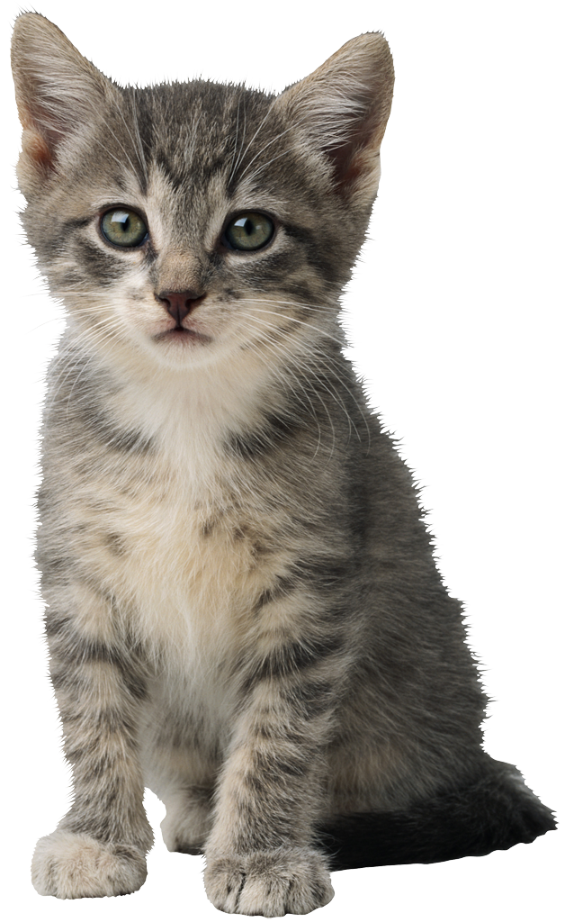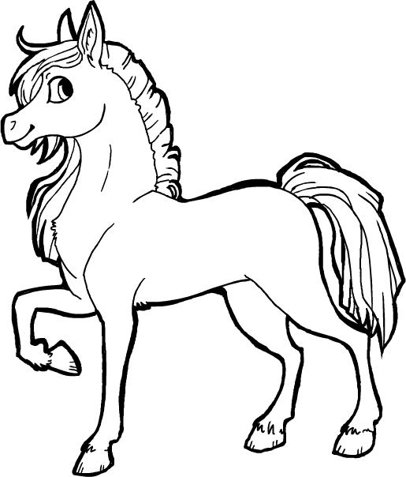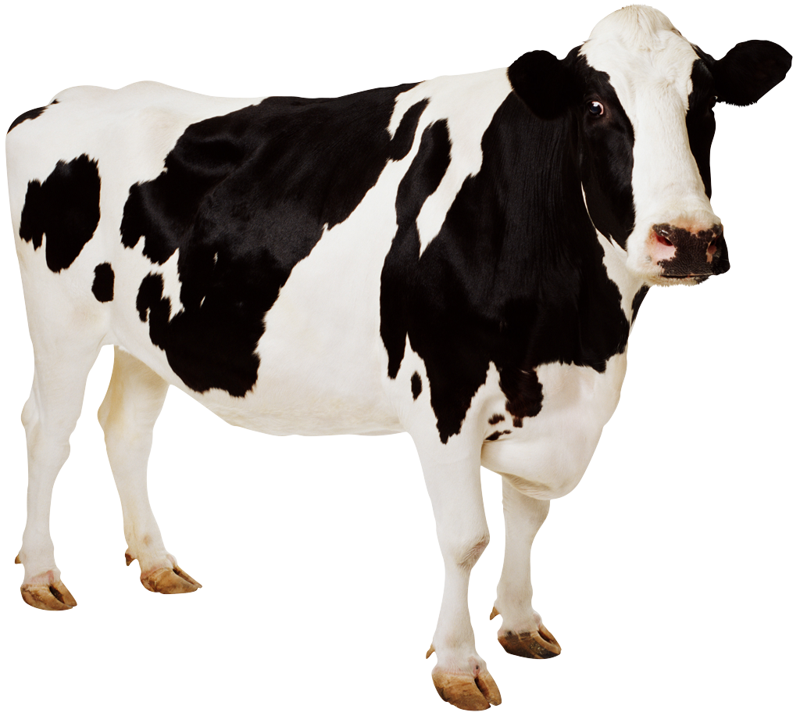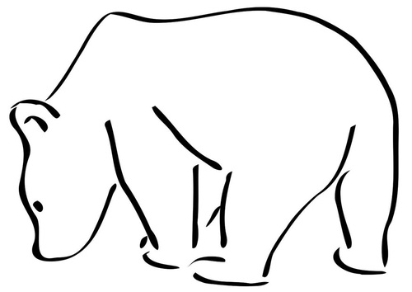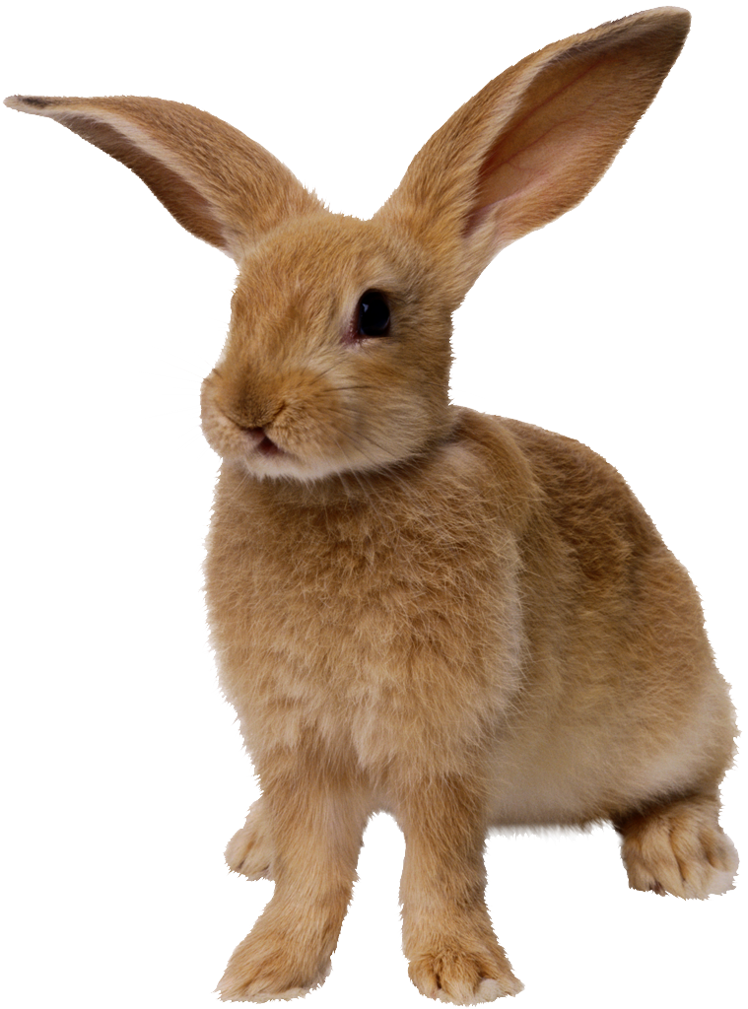

**H**

**G**

**NO**

**F**

**D**

**C**

**B**

**NO**

**YES**

**YES**

**YES**

**NO**

**NO**

**YES**

**NO**

**YES**

**NO**

**YES**

**NO**

**YES**

3. Does it have horns?

3. Does it bark?

3. Does it sleep over winter?

3. Can it climb trees?

2. Can it live in an apartment?

2. Does it eat fish?