**20Q Part B**

*based on Yes and No by Natasha Rozhkovskaya*

Here is a map of missing questions with “yes” and “no” answers. Each endpoint shows a kind of produce. Supply the questions that would result in the correct identification of the fruit.

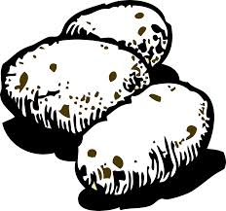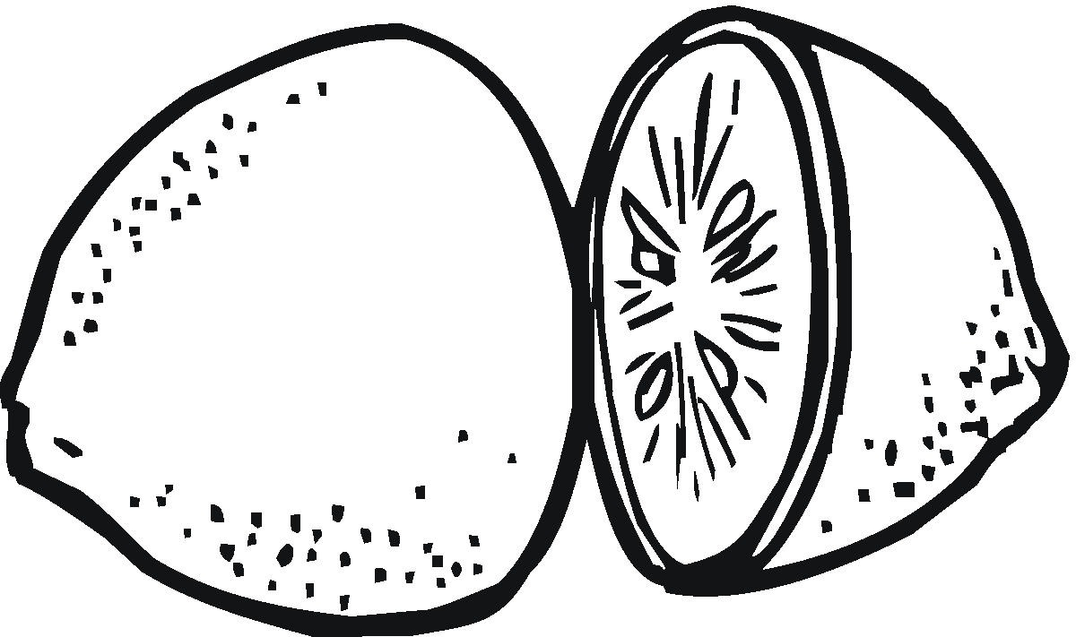

1.

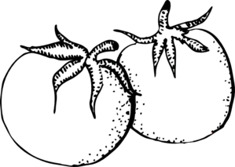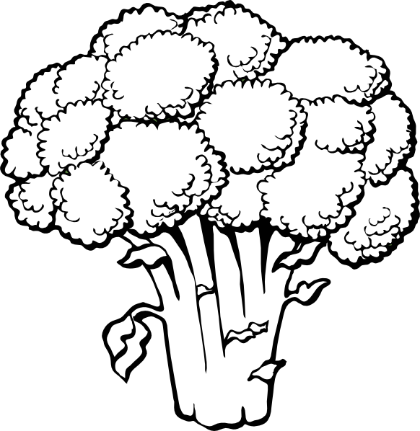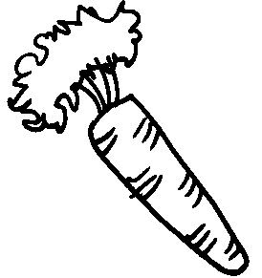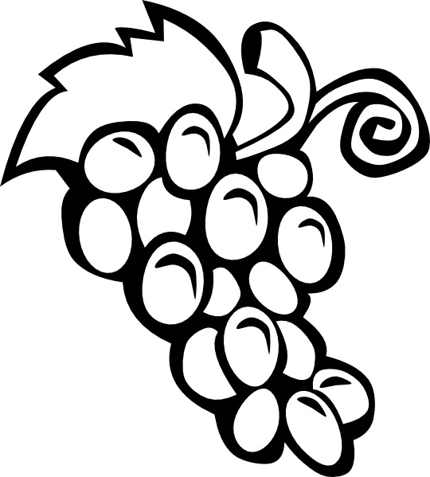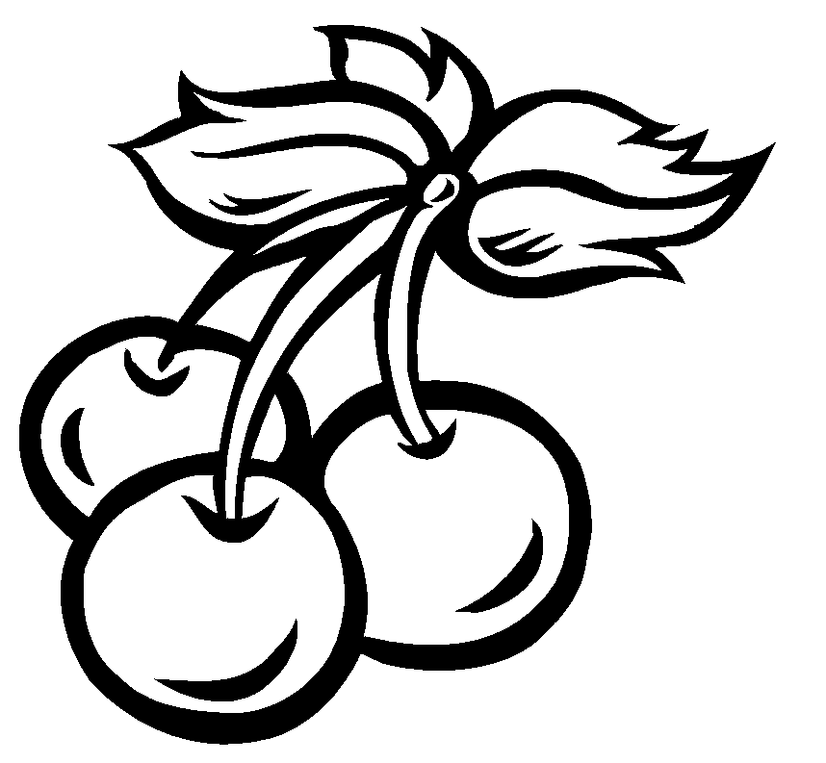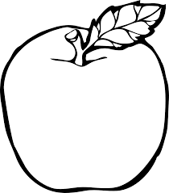

**NO**

**NO**

**YES**

**YES**

**YES**

**NO**

**NO**

**YES**

**NO**

**YES**

**NO**

**YES**

**NO**

**YES**

3nn.

3ny.

3yy.

3yn.

2n.

2y.