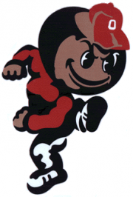

Points Scored | Points on the Scoreboard | # of Push-ups
7 | 7 | 7
3 | 10 | 17
7 | 17 | 34
 | 83 | ???

