Group PS: Noah’s Ark
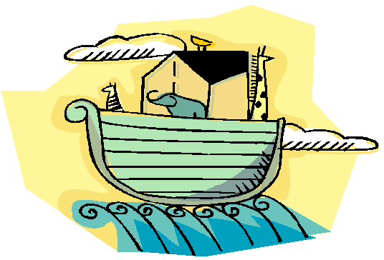
Mr. Noah wants his Ark to sail along on an even keel. The ark is divided down the middle, and on each deck the animals on the left exactly balance those on the right—all but the third deck. Can you figure out how many SEALS are needed in place of the question mark so that they (and the bear) will exactly balance the six zerbras?

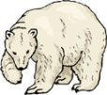 | 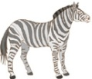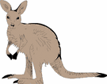
 | ?

Answer: 6 seals
6 seals = 3 zebras

