NEGATIONS
Natasha Rozhkovskaya
Two clowns named YEP and NOPE are best friends. Their favorite game to play is called “Negations.” Whenever YEP states an opinion on something, NOPE immediately makes the opposite statement. Neither clown cares whether they say true things or nonsense.
For example:
YEP: At night, all people are asleep.
NOPE: Some people are not asleep at night. For example, my neighbor plays his drum all night long!
Or:
YEP: It is never too late to learn!
NOPE: Sometimes it is too late to learn. For example, it’s too late for us to learn how to dance classical ballet.

Q1: Why is NOPE’s response in each case above the OPPOSITE of YEP’s?

In most cases, the clowns have no difficulties objecting to each other. But sometimes they struggle to get it right. They once had the following interaction:
YEP: All bunnies can fly.
NOPE: No bunnies can fly!
Neither was sure if NOPE’s reply was correct.

Q2: Is NOPE’s response correct? If so, why? If not, what should it be and why?
Hint: What would be enough to prove YEP’s statement wrong?

Page 2 of 3
For each statement YEP makes below, decide with your group which statement from NOPE (A or B or C) should be the correct “opposite” or “negation.” Also decide which of the statements (A or B or C) are true and which are false.

Q3:
YEP: All kids go to school!
NOPE:
A. Some kids go to school!
B. Some kids do not go to school!
C. All kids do not go to school!
Q4:
YEP: Some books are interesting!
NOPE:
A. Some books are not interesting!
B. All books are interesting!
C. All books are not interesting!

The clowns noticed a few things after a while. See if you notice it too:

Q5: To negate a statement of the type All (…) do (…) it is enough to find _______?________
So that the statement becomes ______?______
Q6: To negate the statement Some (…) do (…) we get the statement ______?______

Find the negations of each of the following. Discuss with your group/

Q7: Some stars are visible in bad weather.
Q8: All princesses wear pink.
Q9: All of Bob’s jokes are terrible.
Q10: Sometimes YEP eats spumoni ice cream.

Page 3 of 3
Q11: Match each statement of YEP on the left with each of NOPE’s responses on the right.
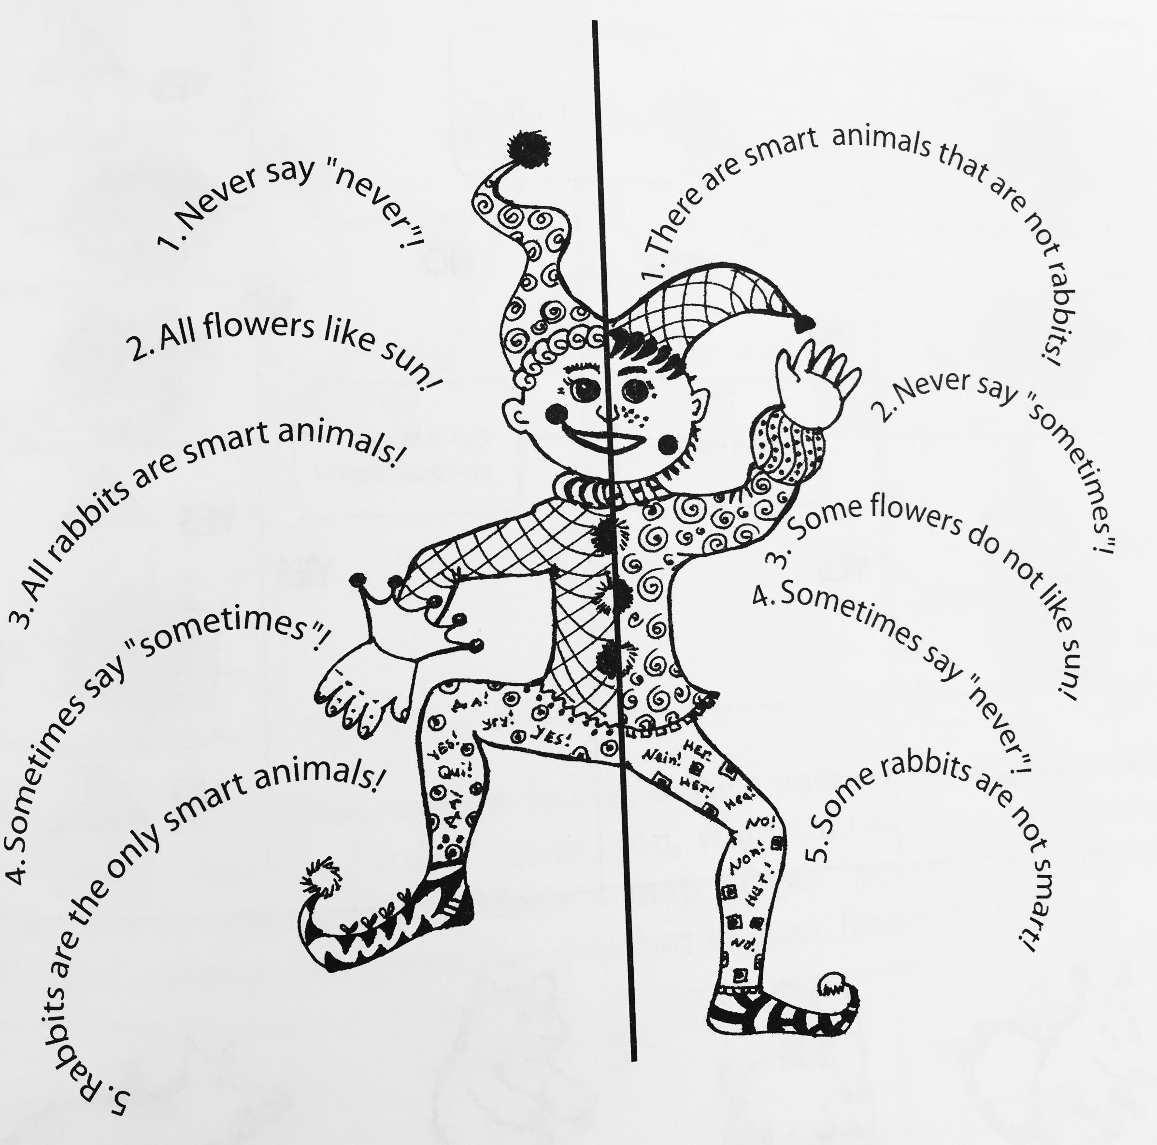

Q12-15: Play the role of YEP by coming up with three statements like the ones you’ve been working with and challenge your neighbor to be NOPE. Let them return the favor. Discuss your answers as you go.

